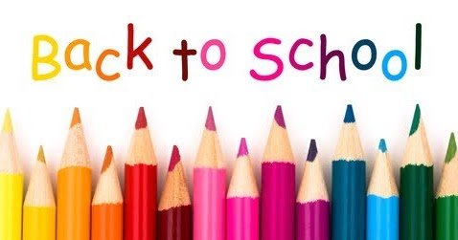
This Photo by Unknown Author is licensed under CC BY
PVMS Parents,
I hope you are all enjoying your summer. Our class supply list for the 2021-2022 school year will be as follows:
ALL STUDENTS
Please label each the following items (It is helpful to have your child’s name or initials on tags of clothing items to prevent them from being placed in lost and found).
- Classroom shoes (They should have a soft sole that can be worn in the gym. Slippers are o.k.).
- One full set of extra clothes (top, bottom, socks, underwear) in a gallon size Ziploc bag labeled with your child’s name.
- Standard size backpack
- Reusable water bottle
- 3 4x6 pictures of student (cubby, box, display)
- Full-time students- insulated lunch box
Please DO NOT label the following items. They will be shared as supplement supplies within our class.
Full-time:
- 1 box facial tissue
- 1 package baby wipes (80+ count)
- 1 box Gallon, Snack, OR Sandwich size Ziploc bags
- 1 package small drinking cups
- 1 container Sanitizing Wipes
Part-time:
- 1 package baby wipes (80+ count)
- 2 Expo BLACK fine tip dry erase markers
- 1 large package of napkins
- 1 soap refill (foaming or non-foaming)
This list can also be found at www.pocatellovalleymontessori.org under the parent resources tab. Please contact me if you have any questions about the supplies.
Thank you!
Miss Amy
amy.holgate.pvms@gmail.com

